Charles Henderson

Reuel Maddela

Harpreet Sidhu

Activity 5 - built from Activity 4

Here is the test page with the header and footer with bootstrap already added:

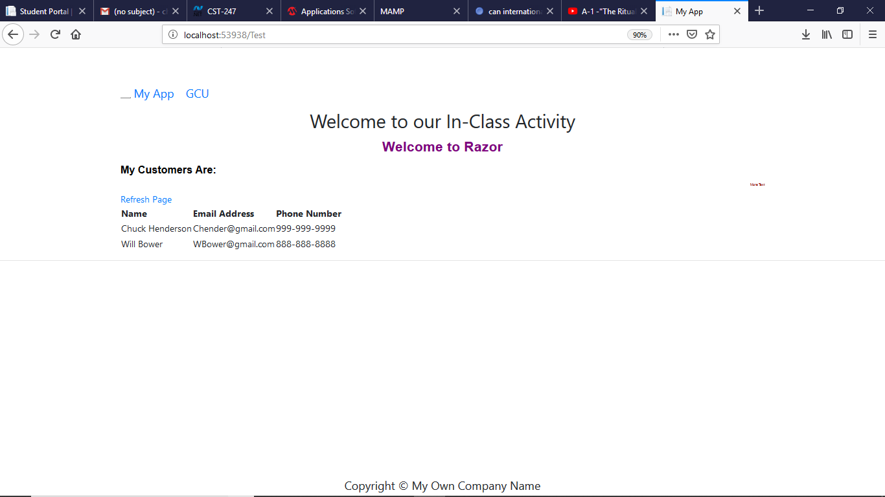

Browser JQuery and Bootstrap allows for resizing:

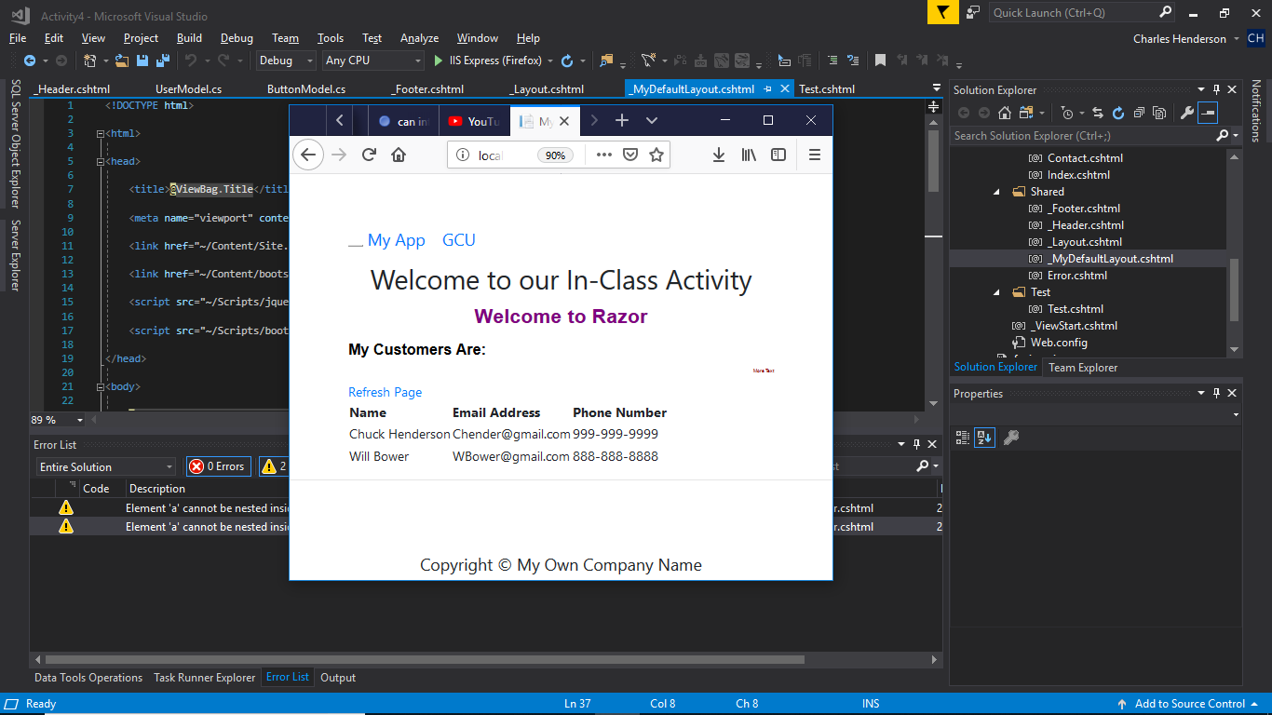

These projects are too large and can’t be uploaded to loudcloud, so the code can be accessed from:

https://github.com/agingdanger/CST-247